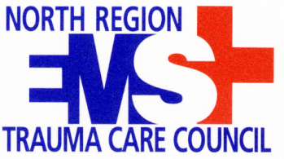
Tuesday, April 22nd, 2014
12-Lead EKG Class
Instructor: Christopher Carleton
9:00am to 5:00pm
Jackson Senate room at Everett Community College

REGISTRATION: $30.00 until April 1st, 2014
$40.00 on or after April 1st, 2014

Registration Closes: April 15th, 2014 or when class is full (85 spots available).
Notifications regarding space for the class will be posted on the NREMS website: www.northregionems.com

Pay on-line via PayPal on the NREMS website or send payment to:
North Region EMS
1130 E. Fairhaven Ave,
Burlington, WA 98233

*Please include registrant’s name on memo line of check or in comments of PayPal

Please complete the following and return to NREMS by:
Fax: 360-336-9236 or E-mail: martina@northregionems.com

First Name
Last Name
Title
Agency
Agency Address
County
Business Phone
Mobile Phone
Email
Method of Payment

If you have any further questions please call the North Region Office at 360-428-0404.
Once you have registered and paid, a confirmation will be sent.

This event is made possible by the Washington State Department of Health EMS & Trauma System Grant and with the supported of the North Region EMS & Trauma Care Council.

